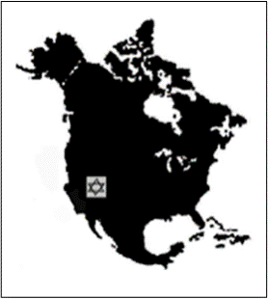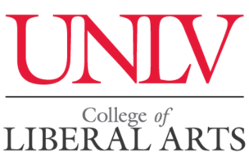

CALL FOR PAPERS
Western Jewish Studies Association Conference University of Nevada-Las Vegas
March 12-13, 2023

Call for paper and panel proposals on all areas of Jewish Studies regardless of discipline, geographical focus, or time period. The WJSA usually includes panels about Jews in the American West, pedagogical aspects in Jewish Studies, and contemporary Jewish issues. It welcomes panels devoted to the major anniversaries of events in Jewish history or important Jewish individuals in 2023, for example:

1993 US Holocaust Memorial Museum Opens, Schindler’s List Premiers 1973 The Yom Kippur War 1948: Israeli War of Independence 1923 Birth of Shimon Peres, British Mandate Goes into Effect, 1st Performance of The Dybbuk 1873 Union of American Hebrew Congregations Founded 1848 Jews in the Revolutions of 1848 1648 Chmielnicki Pogroms
Paper proposals should be no longer than one double-spaced typed page and should be submitted with a short CV that contains contact information. The submission of panels on a common topic is encouraged. Organizers of panels should submit a cover sheet with the title of the panel and the titles of each of the papers and contact information for each presenter, followed by the individual paper proposals and brief CVs. Scholars of Jewish Studies including graduate students are invited to submit proposals for papers/presentations/workshops. A limited number of modest stipends are available for graduate students and overseas scholars who will be presenting papers. Individuals wishing to chair a session should submit their CV.

Although it is planning for an in-person conference, the WJSA will feature virtual panels. If you want to present virtually, you are encouraged to form a panel with other likeminded presenters. Individual virtual proposals will only be accepted if a thematically coherent virtual panel can be formed with other proposals or if the COVID situation necessitates the holding of the conference virtually.

The WJSA annually awards the Baron Award to the best student paper presented at the conference. The winner receives $200.

Although there is no WSJA membership requirement for participation in the conference, a higher registration fee is charged for non-members.

Proposals should be emailed to Lawrence Baron at: lbaron@mail.sdsu.edu The deadline for submission of proposals is November 15, 2022.

