WESTERN JEWISH STUDIES ASSOCIATION MEMBERSHIP
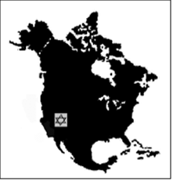
2023-2024
THE WESTERN JEWISH STUDIES ASSOCIATION IS A NONPROFIT ORGANIZATION FOUNDED IN 1995 TO ORGANIZE A JEWISH STUDIES CONFERENCE EVERY SPRING AT ALTERNATING SITES IN THE WESTERN UNITED STATES AND CANADA. THE CONFERENCE SERVES AS A FORUM FOR JEWISH STUDIES SCHOLARS IN THIS REGION TO PRESENT THEIR RESEARCH, DISCUSS PEDAGOGICAL ISSUES, NETWORK WITH COLLEGUES, AND SHARE INFORMATION ABOUT THE FUNDING AND ORGANIZATION OF JEWISH STUDIES PROGRAMS.

Annual Membership Dues for Full-Time Faculty or Fully Employed Members=$50

Graduate Student/Part-Time Faculty, Independent Scholar Dues =$30

NAME:

ADDRESS:

CITY: ZIP

EMAIL ADDRESS:

STATUS (Circle One) Faculty, Part-Time Faculty, Graduate Student, Independent Scholar

UNIVERSITY If faculty or graduate student

ADDRESS)

Submit Dues Via the link below:
https://myrf.sdsu.edu/prod/f?p=MyMerchant:7:::::P7_ACTIVITY_ID:20101

Dues fund the Baron Award for Best graduate paper, conference stipends for graduate students presenting papers, and expenses related to the annual conference.

Return this form to Lawrence Baron, lbaron@sdsu.edu

