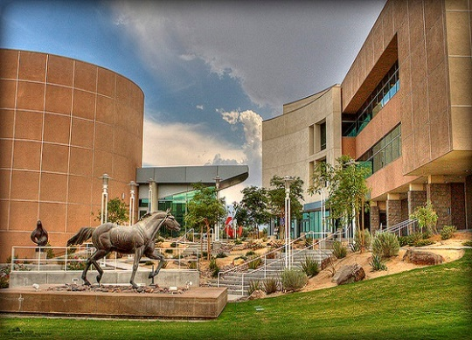

Western Jewish Studies Association
24th Annual Conference
Call for Papers
May 5-6, 2019
California State University, San Bernardino Palm Desert Campus

Scholars of Jewish Studies, including graduate students, are invited to submit proposals for papers and panels on all areas of Jewish Studies regardless of discipline, geographical focus, or time period. The WJSA encourages papers and panels on Jews in the American West and the Coachella Valley in particular, paradigm shifts in Jewish Studies, pedagogy, Israel, and Jewish historical anniversaries commemorated in 2019:
40th anniversary of the Israeli-Egyptian Peace Treaty; 50th anniversary of Golda Meir becoming first woman Prime Minister of Israel; 70th anniversary of the Knesset; 80th anniversaries of World War 2, the White Paper, and ghettoization of Jews in Poland;
Centennials of Primo Levi, Mordecai Anielewicz, Treaty of Versailles, Weimar Republic, Bicentennials of Wissenschaft des Judentums, Isaac Mayer Wise, and Rebecca Gratz founding the Female Hebrew Benevolent Society;
800th anniversary of establishment of Aljama in Toledo;
950th anniversary of Vespasian permitting Yochanan ben Zakkai to establish Yavneh;

Paper proposals should be no longer than one double-spaced typed page and should be submitted with a short CV. Organizers of panels should submit a cover sheet with the title of the panel and titles of each of the papers and names and CVs of each presenter, Individuals wishing to chair a session should submit their CV.

A limited number of modest travel stipends are available for graduate students and overseas scholars presenting papers at the conference.

Although there is no WSJA membership requirement for participation in the conference, there is, a higher registration fee for non-members. Deadline for submission of proposals: November 30, 2018. E-mail proposals should be sent to Lawrence Baron, lbaron@mail.sdsu.edu. For membership information for the WJSA, see www.wjsa.net or contact Lawrence Baron at lbaron@mail.sdsu.edu

